

DEVOPS FOR CLOUD COMPUTING
Assignment

Name:
Tehreem Mirza

Registeration No:
FA22-BSE-088

Section:
BSE-8B

Submitted To:
Sir Muhammad Ibrahim

Installed terraform on windows and also pasted path on environmental variables
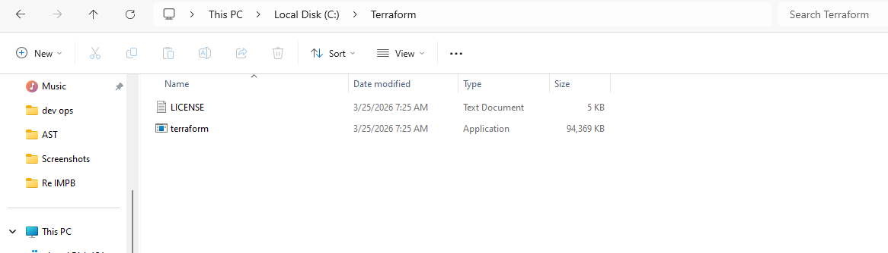

Checking if terraform is installed on windows
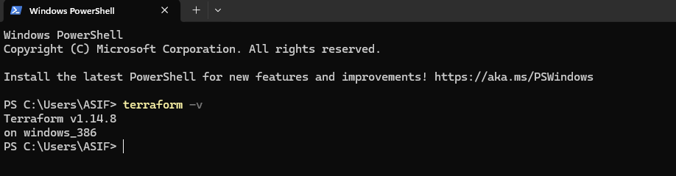

Configuring AWS cli on my PC ---Searched IAM then creating user on AWS
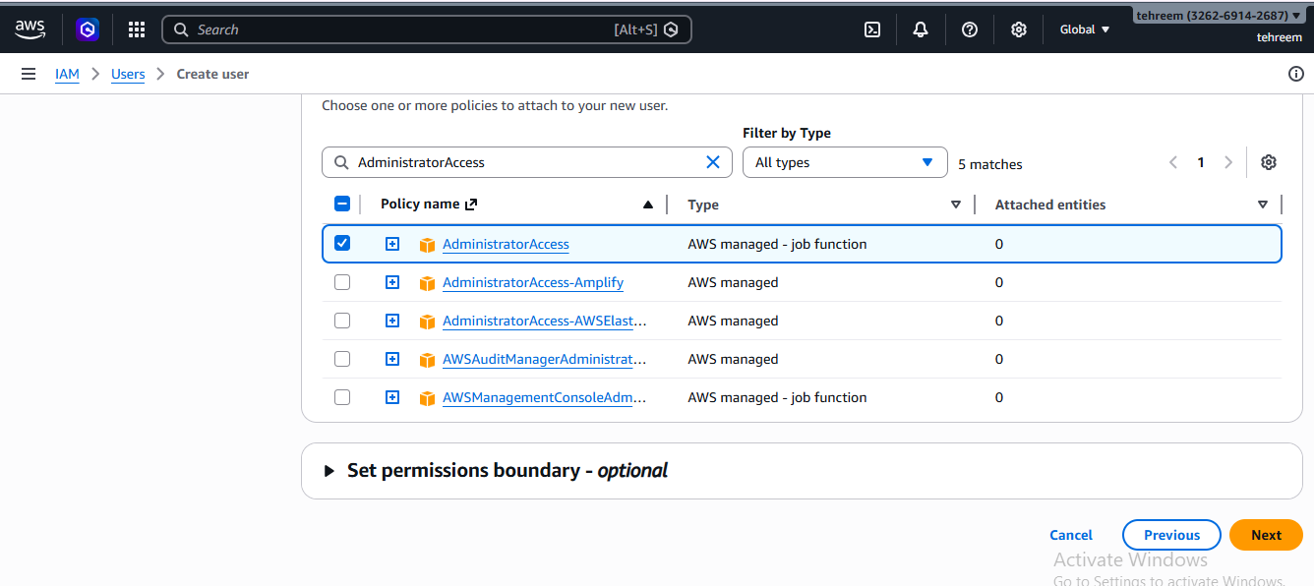
User has been created
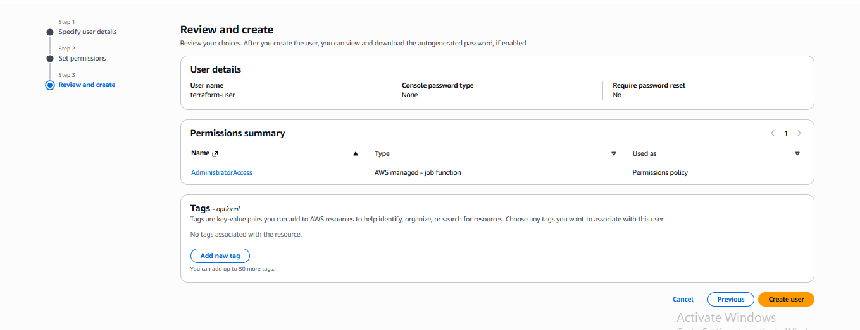

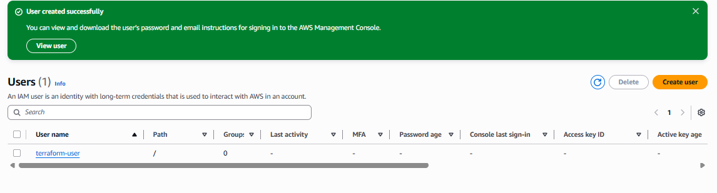

After clicking on the terraform user now creating access keys
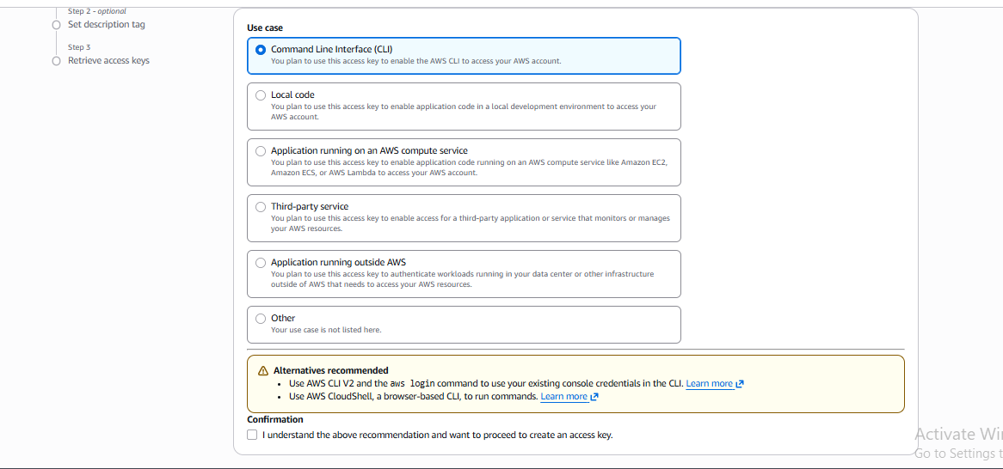

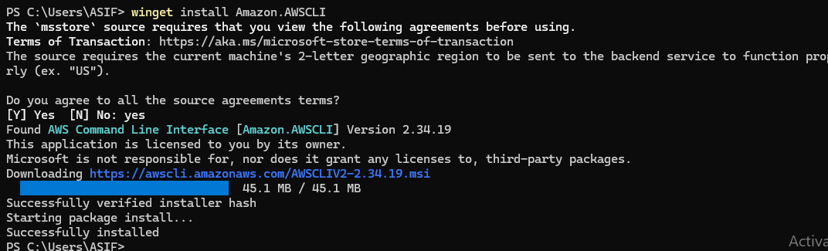

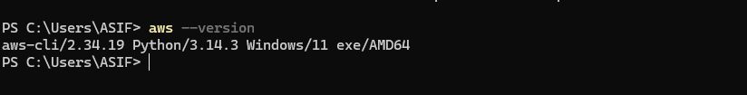
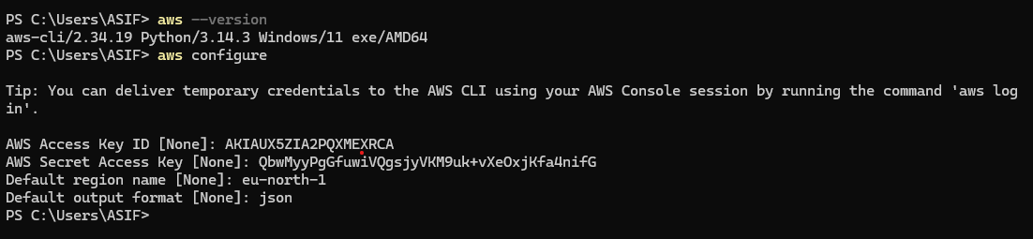

Creating first AWS EC2 instance:
Created main.tf file:
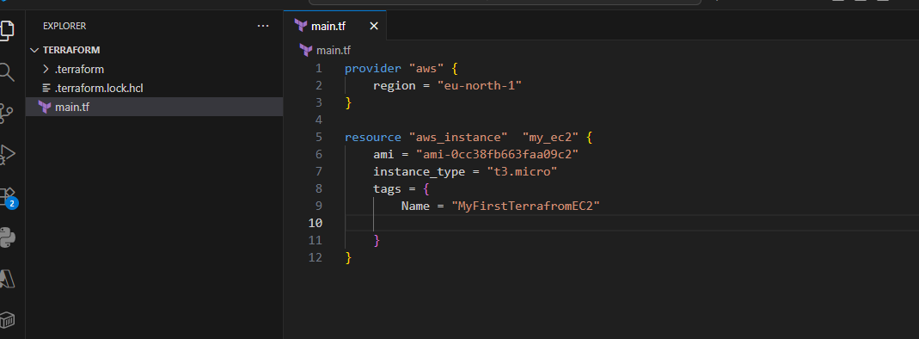

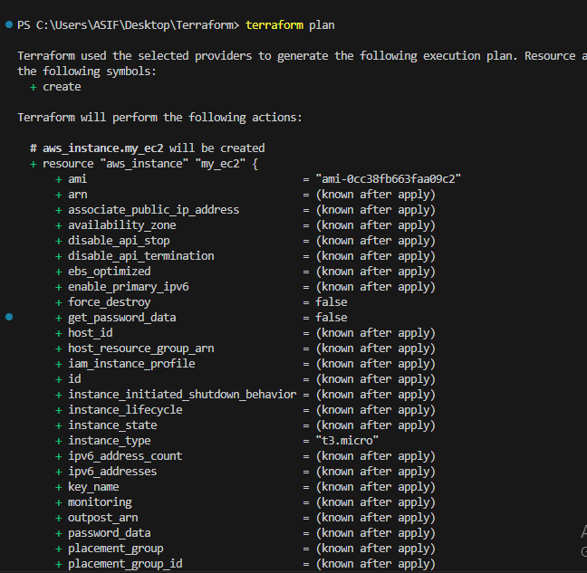
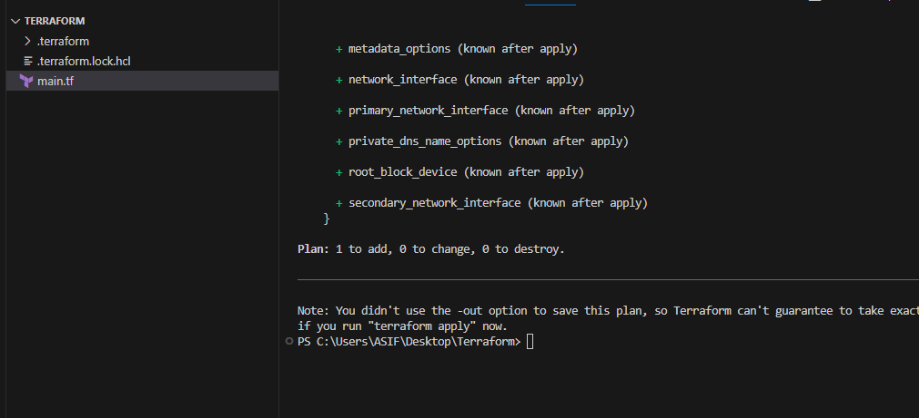

First instance has been created
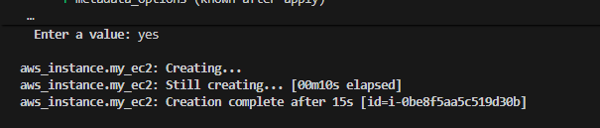

Terraform variables
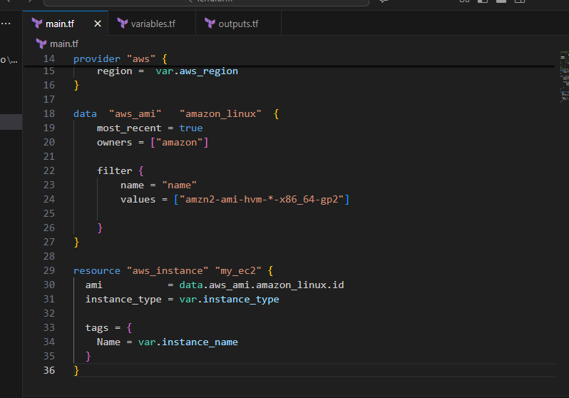
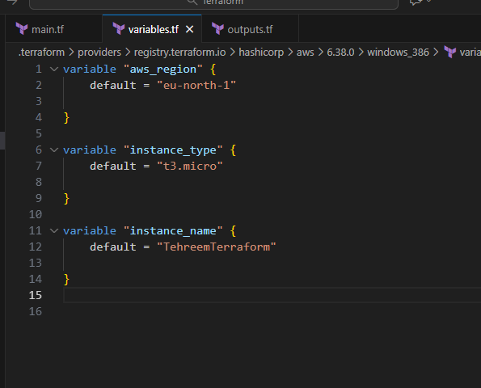

If we don’t want to check manually to aws that our instance is created or not we write output.tf file
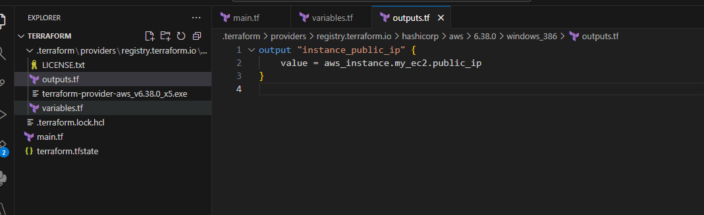

Second instance has been created
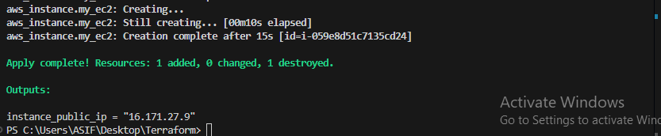

Conditional expression and locals
Main.tf file
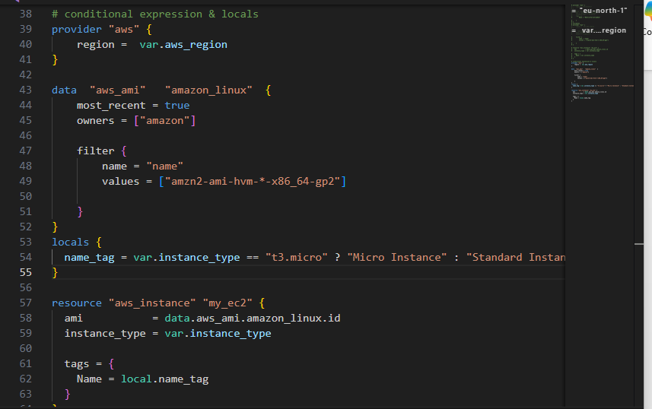Third instance has been created
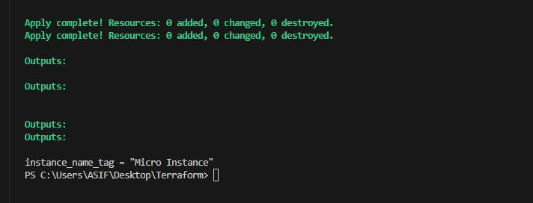

Depends on with:
Main.tf code:
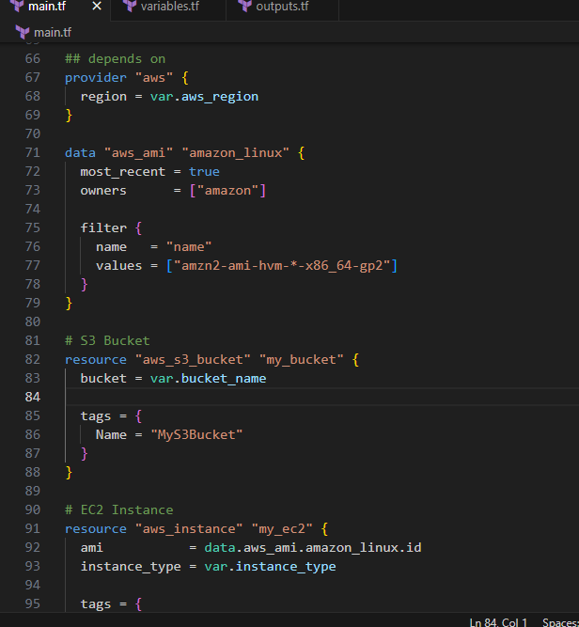
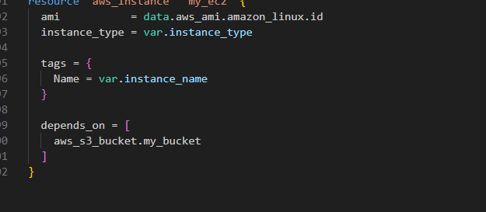

Bucket has been created:
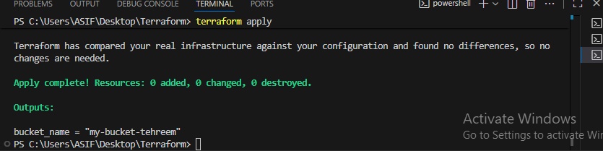

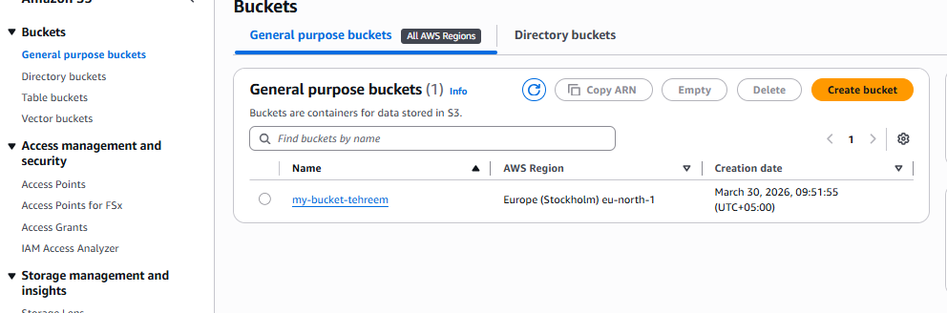

Local vs Remote Modules
Created an ec2-modules folder and in it made some file main.tf, variable.tf and outputs.tf
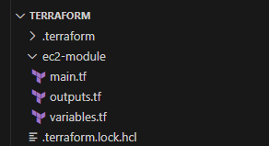

main.tf code
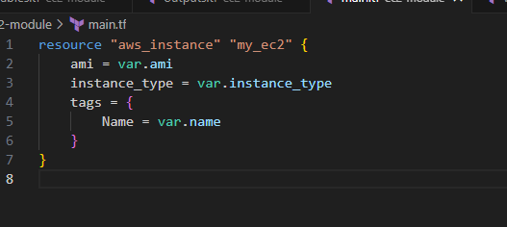

Outputs.tf code
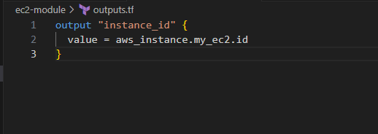
Variables.tf code
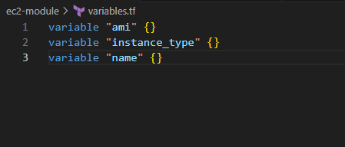

Main.tf file root folder
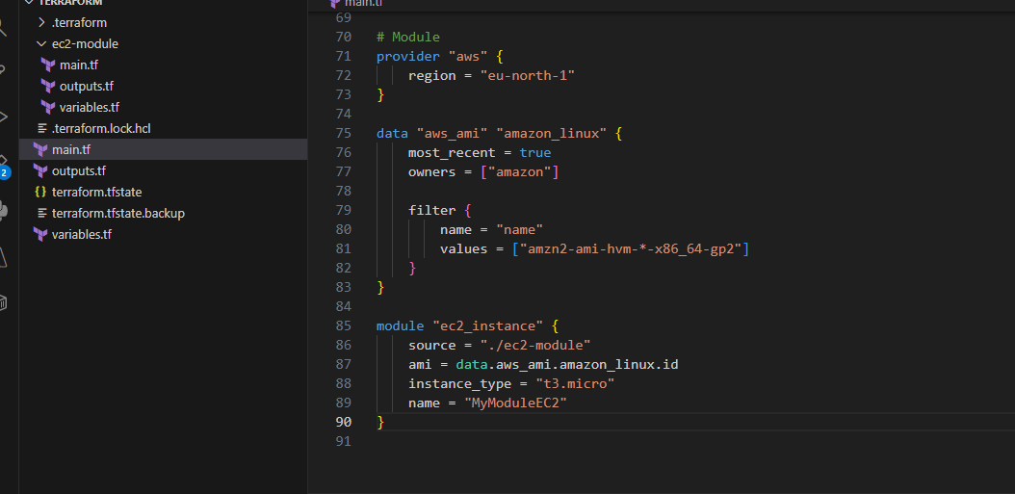

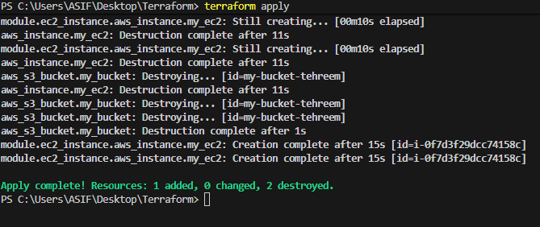
EC2 instance created using a module

Workspace
main.tf code root folder one
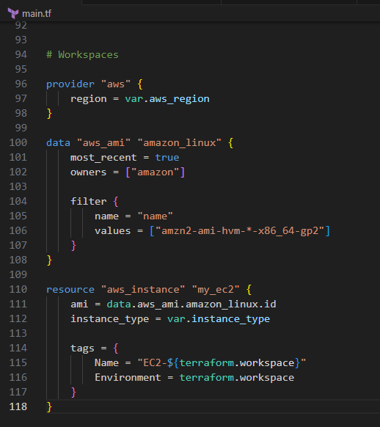

Outputs.tf file
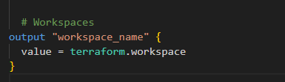
Workspace created
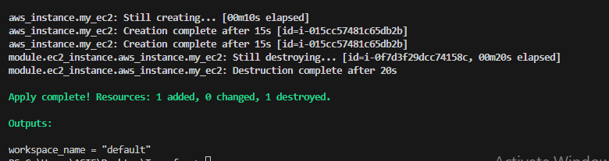
Workspace instance been created
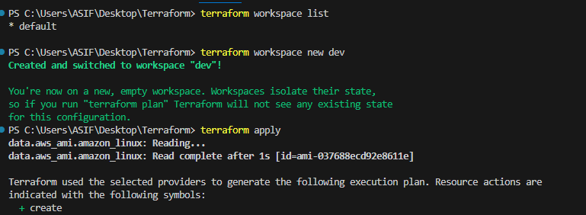
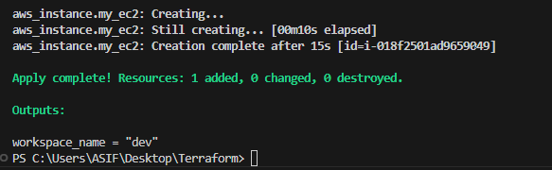
Created a new workspace and doing same thing as above
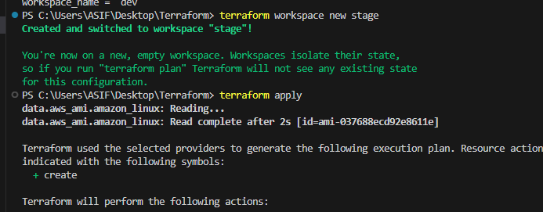
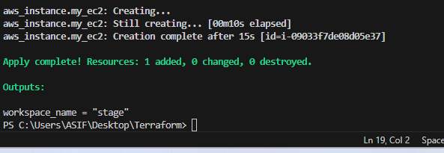

Terraform Registry Modules
Main.tf file code
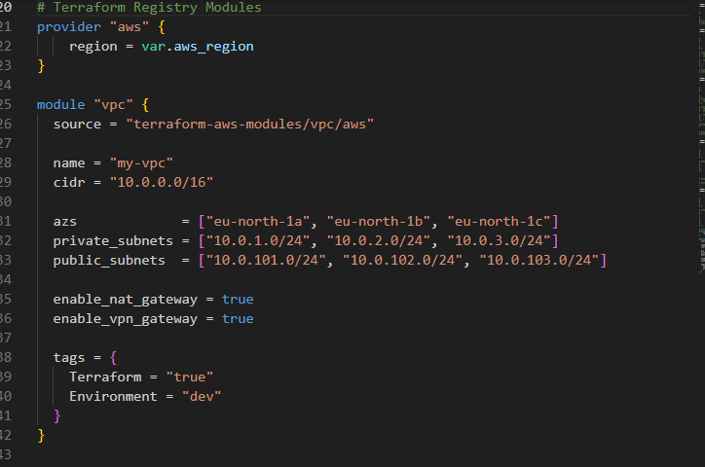
VPC has been created
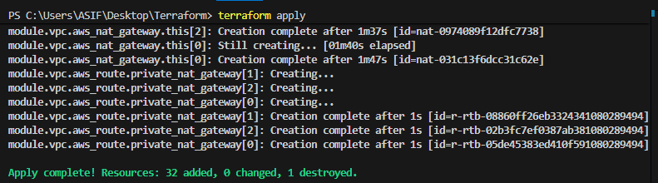
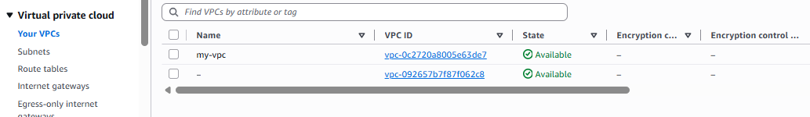

Remote State with S3 & Locking using DynamoDB
Created a backend-setup folder in that created some files main.tf, variables.tf and outputs.tf
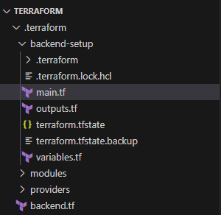

Main.tf code
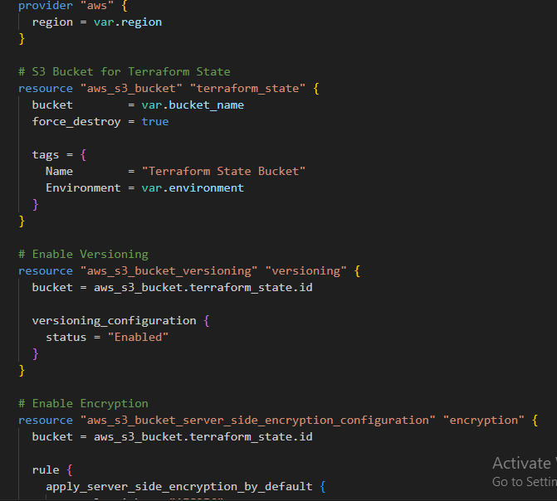
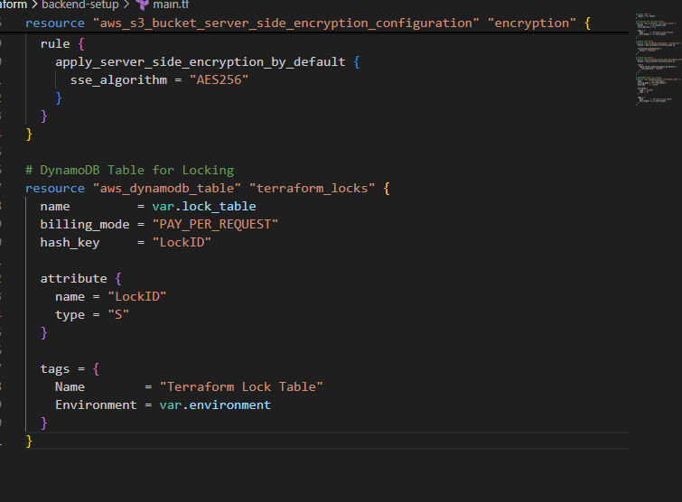

Outputs.tf code
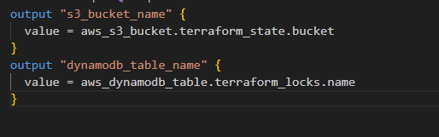

Variables.tf code
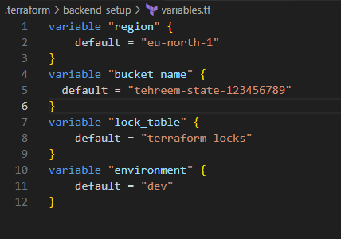

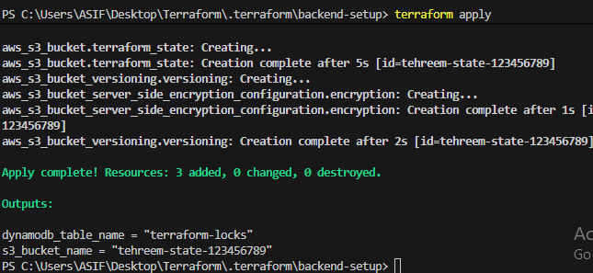

Creation of S3 Bucket for Terraform State Storage
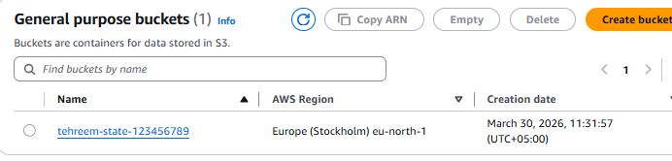
Creation of DynamoDB Table for State Locking


